Subject | : | Web Engineering |  | Date: | 23-01-2026
Course Code | : | CSC-234 |  | Marks: | 60
Examination | : | Final Term | Fall-2025 | Semester: | 7th, 5th
Instructor | : | Syed Nouman Ali |  | Time: | 2 hr

Case Study: University Attendance Management System (UAMS)
Business Rules
- Each class session duration = 90 minutes (1.5 hours)
- Each 3-credit course has exactly 2 classes per week per section
- Teacher marks attendance per session
- Student views own attendance
- Admin manages master data
- Role-based access using JWT
The Relational Data Model is provided separately (students generate entities via JPA Buddy).
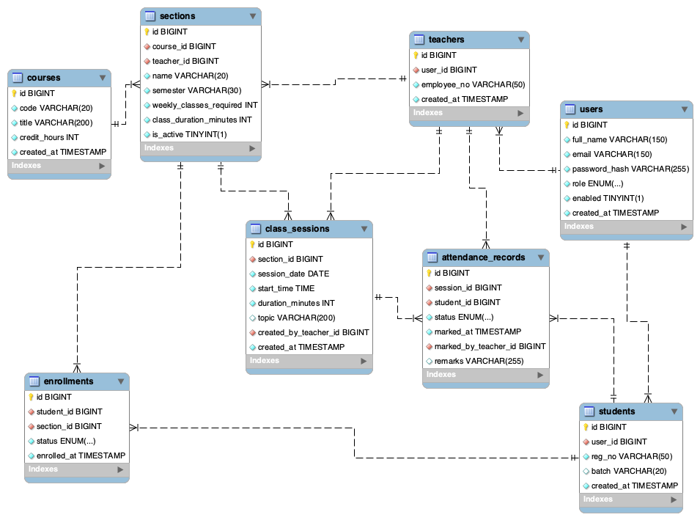

Course Learning Outcomes (CLOs)
CLO | Description
CLO-1 | Design and implement domain models using Spring Data JPA with correct entity relationships and constraints.
CLO-2 | Develop service layer logic enforcing business rules and transactional consistency.
CLO-3 | Design RESTful APIs and test them using JSON request/response patterns.
CLO-4 | Apply role-based security using Spring Security and integrate backend services with React frontend.

SECTION A — ENTITY IMPLEMENTATION (15 Marks)
CLO Assessed: CLO-1

Q1. Implement ClassSession Entity (15 marks)
Write the complete Java entity class for ClassSession including:
- @Entity, @Table
- Fields:
id, sessionDate, startTime, durationMinutes, topic
- Relationships:
  - @ManyToOne Section section
  - @ManyToOne Teacher createdByTeacher
- Default value: durationMinutes = 90
- Lombok allowed

SECTION B — REPOSITORY & JPQL (10 Marks)
CLO Assessed: CLO-1

Q2. Repository Interfaces (6 marks)
Write Spring Data repository methods for:
- ClassSessionRepository
  - findBySectionId(Long sectionId)
- AttendanceRepository
  - existsBySessionIdAndStudentId(Long sessionId, Long studentId)
- EnrollmentRepository
  - existsByStudentIdAndSectionIdAndStatus(...)

Q3. JPQL Query (4 marks)
Write a JPQL query to calculate:
Attendance percentage of a given student in a given section.

SECTION C — SERVICE LAYER & BUSINESS RULES (15 Marks)
CLO Assessed: CLO-2

Q4. Weekly Class Scheduler (7 marks)
Design:
generateWeeklySessions(Long sectionId, LocalDate weekStartDate)
Must enforce:
- For 3-credit course → exactly 2 sessions per week
- Each session = 90 minutes
- No duplicate (section, date, time)
Provide method signature + pseudocode.

Q5. Attendance Marking Logic (8 marks)
Design:
markAttendance(Long sessionId, Long studentId, AttendanceStatus status)
Rules:
- Student must be ENROLLED
- No duplicate attendance
- Only assigned teacher can mark (from SecurityContext)
- Save PRESENT / ABSENT / LATE / LEAVE

SECTION D — REST API DESIGN (10 Marks)
CLO Assessed: CLO-3

Q6. Controller Endpoints (6 marks)
Design REST endpoints:
- POST /api/sections/{id}/sessions/week
- GET /api/sections/{id}/sessions
- POST /api/sessions/{id}/attendance
- GET /api/students/me/attendance?sectionId=
Write mappings + method signatures.

Q7. Postman JSON (4 marks)
Write request bodies for:
- Weekly session generation
- Attendance marking

SECTION E — SPRING SECURITY (5 Marks)
CLO Assessed: CLO-4

Q8. Role-Based Authorization (5 marks)
Define access rules:
Endpoint | ROLE_ADMIN | ROLE_TEACHER | ROLE_STUDENT
/api/admin/** | ✔/✖ | ✔/✖ | ✔/✖
/api/sections/** | ✔/✖ | ✔/✖ | ✔/✖
/api/sessions/** | ✔/✖ | ✔/✖ | ✔/✖
/api/students/me/** | ✔/✖ | ✔/✖ | ✔/✖
Fill allowed/denied.

SECTION F — REACT FRONTEND (15 Marks)
CLO Assessed: CLO-4

Q9. React Component Design (7 marks)
Design:
- TeacherAttendancePage
- StudentAttendancePage
Show:
- Component hierarchy
- State variables
- Props
- Bootstrap layout (table, dropdown, buttons)

Q10. Axios + JWT Integration (4 marks)
Write React Axios code to:
- Call GET /api/students/me/attendance
- Pass JWT in header
- Store result in state
- Render in Bootstrap table

Q11. Protected Routing (4 marks)
Using React Router:
- Protect /teacher/* for ROLE_TEACHER
- Protect /student/* for ROLE_STUDENT
- Redirect unauthorized users
Write route-level pseudocode.

CLO–QUESTION MAPPING SUMMARY
Section | Question | Marks | CLO
A | Q1 | 15 | CLO-1
B | Q2–Q3 | 10 | CLO-1
C | Q4–Q5 | 15 | CLO-2
D | Q6–Q7 | 10 | CLO-3
E | Q8 | 5 | CLO-4
F | Q9–Q11 | 15 | CLO-4
Total |  | 60

